Banners
The Banners module displays banner advertising associated with Vendor accounts. Banners can be plain text, HTML, a static image, an animated image or they can execute a script such as JavaScript. The number and layout of banners can be modified and if there are more banners available than the number chosen to display, then different banners will be displayed each time the page is visited or refreshed. Users must be granted Edit Module permissions to add, edit and manage banners.

Different types of banners can be associated with a vendor account and displayed using the Banners module. Five sizes of image banners are provided: Banner, MicroButton, Button, Block and Skyscraper. The Banner Type 'Banner' can be displayed either using a Banners module, or by adding the [BANNER] skin object to the theme applied to the site or to a page of the site. The [BANNER] skin object can be enabled or disabled on the Admin > Site Settings page and is a site wide setting. This can be set to either Site or Host.
Below are examples of the industry standard sizes for banner images. These sizes are recommendations only.
Banner: 468 x 60 pixels. The banner type called "Banner" can be displayed either using a Banners module, or it can display where ever the [BANNER] theme object is included in the theme applied to a page.
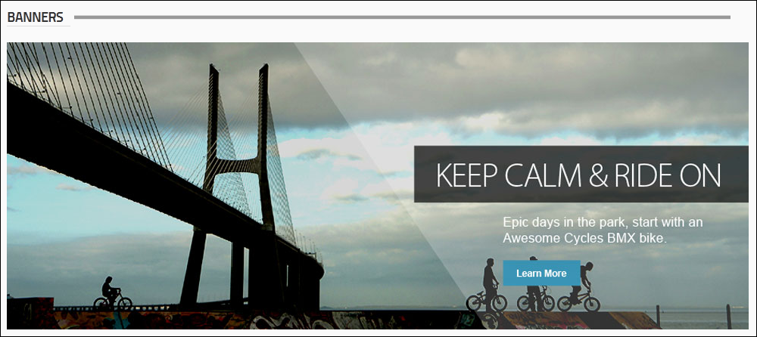
Micro Button: 120 x 60 pixels

Button: 120 x 90 pixels

Block: 125 x 125 pixels

Skyscraper: 120 x 600 pixels
Script Banner: Script type banners can contain JavaScript which is executed when the banner is shown on the site.
Text Banner: Text banners can be either plain text or HTML. Stylesheet styles are applied.
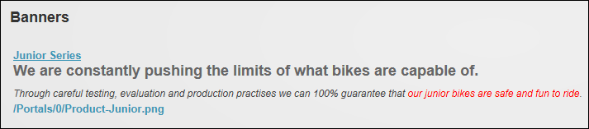

Displaying Banners
Editors can display and modify host or site vendor banners by selecting Edit > Banner Options from the module actions menu. Site banners are those managed on and exclusive to this site whereas Host banners are managed on the main Host site and are available to all sites within this DNN installation.
Banners can be restricted by a single banner type or all types can be displayed. Likewise banners can be restricted by banner group (banners can be added to groups when they are created and the maximum number of banners to be displayed at one time can be set.
Optional settings that control how the banners display include vertical or horizontal orientation. It banners are displayed horizontally then the column width should be entered to space banners evenly across the page. E.g. Width is set at 300 pixels in the below image. Banners uses a table to layout banners on the page. Because each banner is displayed inside its own table cell, the layout of banners on the page can be changed by defining the height and width of each cell and adding cell padding. A border can be displayed around each banner by setting the border pixel width, setting the border color using a hex number (#6495ED) or a color code (CornflowerBlue), and then setting the cell padding between banners and the border. The banners can be further spaced by entering row height and column width pixel values.
Finally, all banners can function as buttons to the one location by entering a redirect page.
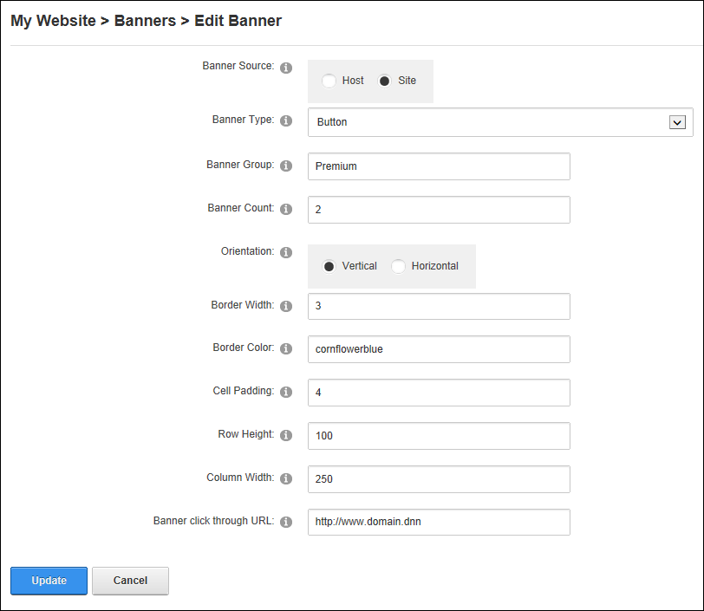
Editing Banners

Displaying Banners Vertically
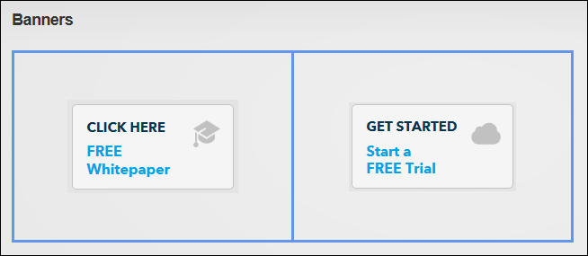
Displaying Banners Horizontally with a CornflowerBlue border

Troubleshooting: Image Not Displaying
If an image doesn't display in the Banners module, ensure the Hidden attribute check box is not selected as this will hide the image. See "Managing File Properties". Once this is done, return to the Banners module and refresh the browser to see if this fixes the problem changes. If the image is still not displaying then check the module caching period and reduce if required. See "Configuring Cache Settings for a Module".
